**Develop ELT and Staging in Snowflake**

**Questions**

* Name of your database: **IMT577_DW_JWALA_SURESH**
* What went well for you?
  + Created the data warehouse
  + Created stages and staging tables
  + Successfully loaded data from Azure Blob Storage to the tables
* What didn’t go well?

While loading data from Azure Blob Storage faced some issues due to data type mismatch for Created Date and Modified Date columns in the provided data. Verified the values in the CSV and tried using Timestamp and Date data types. Reached out to Professor and learned that VARCHAR was the correct data type to be used and thus fixed the issue.

* Did you learn something significant to share with your peers?
  + I learned that while creating the staging tables we should enter the columns in the exact order as given in the CSV files. I got an error while creating one of the stage tables and that’s when I realized this. Also, I tried out giving a different column name than in the CSV to see if that will cause any issue. Trying out like this helped me understand what I need to focus on while creating the stage tables.
  + Stages and staging tables can have different names, but it is easier to use the same name to avoid confusion.
* Do you have any tips or tricks to share with the class?
  + To ensure that I am not missing any steps while creating the staging tables, I created a document with the step-by-step procedure explained in the video. This helped me to avoid rewatching the videos and save time. Also, I believe this will be useful for future reference.
  + Including all CSV files as separate sheets, I created a single Google sheet document. This helped me to easily toggle between different data sheets and ensure that I am not missing out on any columns while creating the stage tables.
  + Referring to the normalized ERD model while creating the staging tables was also helpful to ensure that the right data type is used for columns.

**Screenshots**

* **Screenshot of your database in Snowflake. Make sure it includes the Staging tables**

* **Screenshot of your database Stage. This is different from your staging tables**

* **Screenshot of two stage tables datasets demonstrating that they are populated**

1. **STAGE_STORE Table**

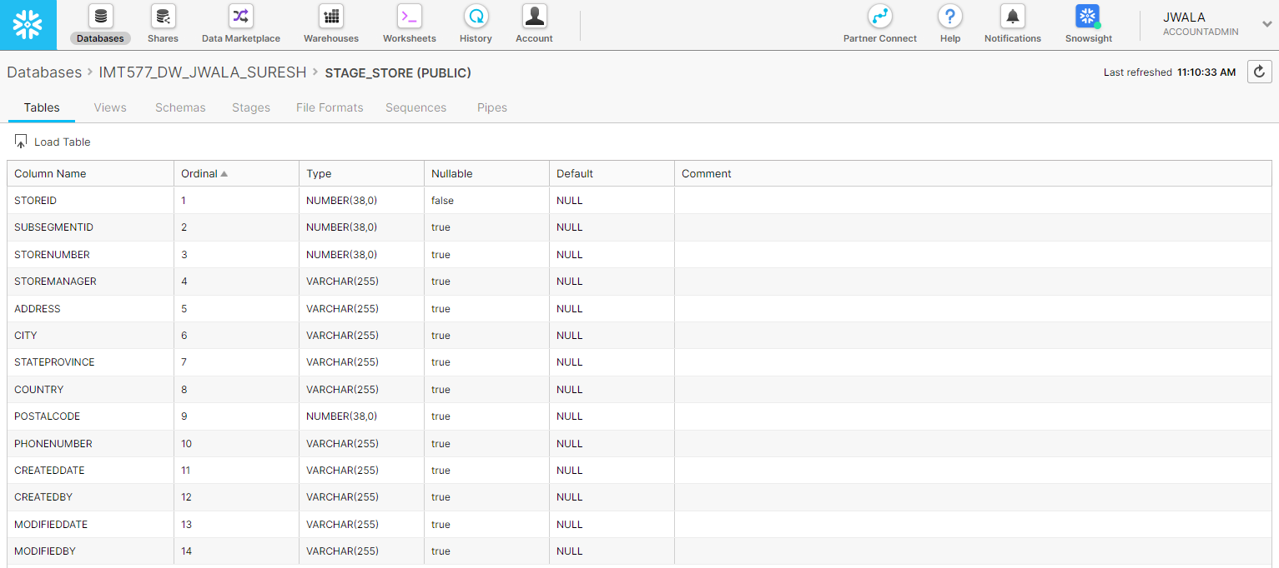

1. **Stage_ProductType Table**

